ASSIGNMENT NO.1
TITLE: Develop an application based on Java environment setup, JDK/JRE/JVM, variables, methods and constructors. and demonstrate the implementation of the concepts through suitable examples.
Problem Statement: Develop an application based on Java environment setup, JDK/JRE/JVM, variables, methods and constructors. and demonstrate the implementation of the concepts through suitable examples.
Learning Objectives: Understand the theoretical concepts, implement them in Java programs, analyze outputs, and apply the concepts to solve practical programming problems.
Theory:
Java environment setup, JDK/JRE/JVM, variables, methods and constructors. forms an important component of Java programming. Students should understand the underlying concepts, architecture, advantages, use cases, and implementation methodology. The exercise should focus on understanding the design principles, coding practices, execution flow, and practical applications of these concepts in software development. Detailed study should include syntax, APIs, execution process, and real-world applications.
JDK (Java Development Kit)
JDK is a software package used for developing Java applications. It contains the Java compiler (javac), JRE, debugger, and other development tools. Developers use the JDK to write, compile, and run Java programs.
JRE (Java Runtime Environment)
JRE provides the environment required to run Java applications. It includes the JVM and essential Java libraries needed for execution. It cannot be used to compile Java programs because it does not include development tools.
JVM (Java Virtual Machine)
JVM is the virtual machine responsible for executing Java bytecode. It converts bytecode into machine code that the operating system understands. JVM enables Java's "Write Once, Run Anywhere" feature by making Java platform-independent.
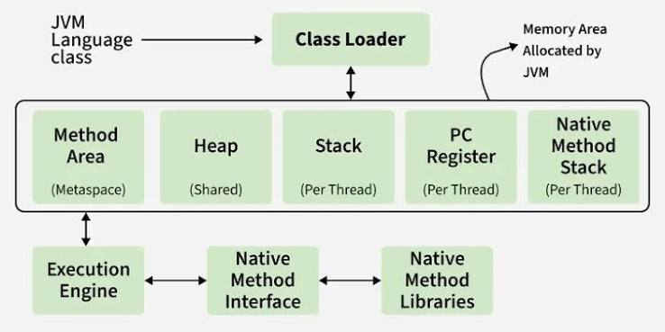
This diagram shows the internal architecture of the Java Virtual Machine (JVM). It illustrates how Java classes are loaded, stored in different memory areas (Heap, Stack, Method Area, etc.), and executed by the Execution Engine using native libraries when required.
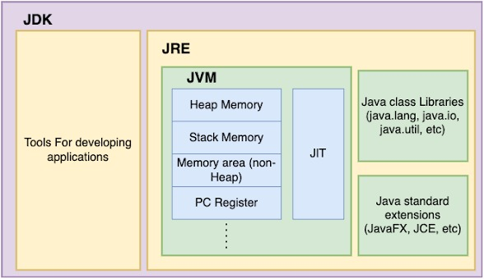
This diagram explains the hierarchy of JDK, JRE, and JVM. The JDK contains development tools, the JRE provides the runtime environment with Java libraries, and the JVM executes Java bytecode using memory management and the Just-In-Time (JIT) compiler.
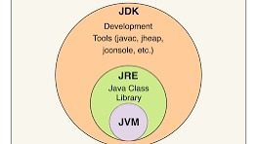
This image provides a simple representation of the relationship between JDK, JRE, and JVM. It shows that the JVM is a part of the JRE, while the JRE itself is included within the JDK, making the JDK the complete package for developing and running Java applications.
Conclusion:
This assignment helped in understanding the Java programming environment, including the roles of JDK, JRE, and JVM, and how they work together to develop and run Java applications
Questions:
- Explain the main concept used in Java environment setup, variables and methods.
Ans. Java environment setup involves installing the JDK and configuring the system to compile and run Java programs. Variables store data, while methods are reusable blocks of code that perform specific tasks and improve program organization.
- What are the real-world applications?
Ans. Java is widely used in developing web applications, Android mobile apps, enterprise software, and desktop applications. It is also used in banking systems, cloud computing, and big data technologies due to its platform independence and reliability.
Name: Aarushi Raizada
PRN: 25070122002
Class: A-1

